**Overall Survival with Palbociclib Plus Aromatase Inhibitor Versus Aromatase Inhibitor Alone in Postmenopausal Women and in Men With HR+/HER2– Metastatic Breast Cancer: A Large Real-World Study in US Clinical Practice**

**Document Type:**

Manuscript

**Running Title:**

P-Reality-X

**Authors:**

Hope S. Rugo, MD; Adam Brufsky, MD, PhD; Xianchen Liu, MD, PhD; Benjamin Li, PhD; Lynn McRoy, MD; Connie Chen, PharmD; Rachel M. Layman, MD; Massimo Cristofanilli, MD; Mylin A. Torres, MD; Giuseppe Curigliano, MD, PhD; Richard S. Finn, MD; Angela DeMichele, MD

**Target Publication/Congress:**

*NPJ Breast Cancer*

**Client/Sponsor Contact:**

Pfizer Inc

**ICON Contact:**

Jill Shults, PhD

**Draft and Date:**

Draft 1

February 17, 2022

**ICON Project Number:**

PAL21190.1144

cid:image001.gif@01D3BBB8.62308580

ICON plc

731 Arbor Way, Suite 100

Blue Bell, PA 19422

**Timeline:**

|  |  |  |
| --- | --- | --- |
| **Stage** | **Date** | |
| ICON to send First Draft to authors | February 17 | |
| First Draft Comments Due | February 24 | |
| ICON to prepare second draft, only if additional data requested during Draft 1 review | 7 business days for ICON D2 development  3 business days for author review | |
| ICON to send Final Draft for Author/IP Approval | March 17 | |
| Final Draft Author/IP Approval Due | March 24 (Authors)*  March 31 (IP)† | |
| Final Check | March 31 – April 1 | |
| Submission to *NPJ Breast Cancer* | April 1 | |
| **\*Timeline assumes all data are available and provided to ICON prior to initiation of draft 1 development and is dependent upon timely reviews and extend of edits by Pfizer and authors.**  **† IP Timing for manuscript requires 10 business days be allotted for review/approval** | |

Submission Information

Article type: Article

Title: Overall Survival With Palbociclib Plus Aromatase Inhibitor Versus Aromatase Inhibitor Alone in Postmenopausal Women and in Men With HR+/HER2– Metastatic Breast Cancer: A Large Real-World Study in US Clinical Practice

Running Head: Overall Survival of Palbociclib + AI in Real-World Practice

Abstract: Copy and paste

Group Authorship: No

The corresponding author has read the journal policies on author responsibilities and submits this manuscript in accordance with those policies. Confirm

Number of authors: 12

Submitter: Are you the corresponding author? Yes

Authors:

**Dr. Hope S. Rugo, MD**

Profession: Medical Oncology

Institution: University of California San Francisco Helen Diller Family Comprehensive Cancer Center

Department: Medicine

Address: 1600 Divisadero St, San Francisco, CA 94115, USA

Phone: 415-353-7070  
Email: [hope.rugo@ucsf.edu](mailto:hope.rugo@ucsf.edu)

**Dr. Adam Brufsky, MD, PhD**

Profession: Medical Oncology

Institution: UPMC Hillman Cancer Center, University of Pittsburgh Medical Center

Department: Oncology

Address: 300 Halket Street, Pittsburgh, PA 15213, USA

Phone: 412-641-6500  
Email: [brufskyam@upmc.edu](mailto:brufskyam@upmc.edu)

**Dr. Xianchen Liu, MD, PhD**

Profession: Clinical Research

Institution: Pfizer Inc

Department: Oncology

Address: 235 42nd St, New York, NY, 10017, USA

Phone: 908-901-1382  
Email: [Jasonxc.Liu@pfizer.com](mailto:Jasonxc.Liu@pfizer.com)

**Dr. Benjamin Li, PhD**

Profession: Biostatistics

Institution: Pfizer Inc

Department: Global Biometrics and Data Management

Address: 235 42nd St, New York, NY, 10017, USA

Phone: 212-733-2294  
Email: [Benjamin.Li@pfizer.com](mailto:Benjamin.Li@pfizer.com)

**Dr. Lynn McRoy, MD**

Profession: Clinical Research

Institution: Pfizer Inc

Department: Oncology

Address: 235 42nd St, New York, NY, 10017, USA

Phone: 212-733-1511  
Email: [Lynn.McRoy@pfizer.com](mailto:Lynn.McRoy@pfizer.com)

**Dr. Connie Chen, PharmD**

Profession: Clinical Research

Institution: Pfizer Inc

Department: Oncology

Address: 235 42nd St, New York, NY, 10017, USA

Phone: 212-733-2323  
Email: [Connie.Chen@pfizer.com](mailto:Connie.Chen@pfizer.com)

**Dr. Rachel M. Layman, MD**

Profession: Medical Oncology

Institution: The University of Texas MD Anderson Cancer Center

Department: Oncology

Address: 1515 Holcombe Boulevard, Unit 1354, Houston, TX 77030, USA

Phone: 713-745-8401  
Email: [RLayman@mdanderson.org](mailto:RLayman@mdanderson.org)

**Dr. Massimo Cristofanilli, MD**

Profession: Medical Oncology

Institution: Weill Cornell Medicine

Department: Division of Hematology-Oncology

Address: Landson House, LH-204

New York, NY 10021, USA

Phone: (646)-962-2330  
Email: [mac9795@med.cornell.edu](mailto:mac9795@med.cornell.edu)

**Dr. Mylin A. Torres, MD**

Profession: Medical Oncology

Institution: Winship Cancer Institute, Emory University School of Medicine

Department: Oncology

Address: 1365 Clifton Rd. NE, Building A, 1st Floor, Rm. 1307A, Atlanta, GA 30322, USA

Phone: 404-778-3473

Email: [matorre@emory.edu](mailto:matorre@emory.edu)

**Dr. Giuseppe Curigliano, MD**

Profession: Medical Oncology

Institution: European Institute of Oncology, IRCCS and University of Milano, Milan, Italy

Address: Via Ripamonti 435, 20141 Milano

Department: Oncology and Hemato-Oncology

Country: Italy

Phone: 0039-02-57489788  
Email: [giuseppe.curigliano@ieo.it](mailto:giuseppe.curigliano@ieo.it)

**Dr. Richard S. Finn, MD**

Profession: Medical Oncology

Institution: David Geffen School of Medicine at University of California Los Angeles

Department: Oncology

Address: 2825 Santa Monica Blvd, Suite 200, Santa Monica, CA 90404, USA

Phone: 310-586-2091  
Email: [RFinn@mednet.ucla.edu](mailto:RFinn@mednet.ucla.edu)

**Dr. Angela DeMichele, MD**

Profession: Medical Oncology

Institution: Abramson Cancer Center, University of Pennsylvania

Department: Oncology

Address: 3400 Civic Center Blvd, Philadelphia, PA 19104, USA

Phone: 215-349-5730

Email: [Angela.DeMichele@uphs.upenn.edu](mailto:Angela.DeMichele@uphs.upenn.edu)

Subject terms: Health Sciences/Oncology/Cancer/Breast Cancer

Springer Nature is committed to increasing transparency in the peer review process. We have partnered with Research Square to provide a private author dashboard, where you can: •Get real-time access to the status of your manuscript throughout peer review via a peer review timeline.

•Access free resources and optional services which can help you improve your manuscript. Use of these services is confidential between you and Research Square, is not shared with the editors of the journal and does not have any impact on editorial decisions.

Springer Nature works with Research Square to provide this service and your personal data will be shared with Research Square for this purpose. For more information on how we use your personal data please see Springer Nature's privacy policy. If you have any concerns please contact [npjbreastcancer@nature.com](mailto:npjbreastcancer@nature.com).

I understand that my manuscript and associated personal data will be shared with Research Square for the delivery of the author dashboard. Confirm

Competing interest: Yes, the authors have competing interests as defined by Nature Portfolio, or other interests that might be perceived to influence the results and/or discussion reported in this paper. These interests are listed in a paragraph at the end of the manuscript.

Copy and Paste COIs

Clinical trial: Yes/No

If yes: Is this study registered on a publicly accessible web site? Yes/No

If no, please explain why your study is not registered

Dual publication: No, the results/data/figures in this manuscript have not been published elsewhere, nor are they under consideration (from you or one of your Contributing Authors) by another publisher.

Submission of a manuscript will be taken to imply (a) that Authors have obtained permission to publish from their employers or institutions, if they have a contractual or moral obligation to do so; (b) that approvals are held from any persons acknowledged, or cited as having provided personal communication; and (c) that all authors have seen and approved the final version of the submitted paper.

Other than as an abstract details of any preliminary publication must be given in the submission letter. Authors must declare that no part of the manuscript is currently under consideration for publication elsewhere.

Word Count: XX Words

Open Access: I confirm that I understand npj Breast Cancer is an Open access journal that levies an article-processing charge per article accepted for publication. By submitting my article I agree to pay this charge in full if my article is accepted for publication. Charges for specific manuscript types are outlined here.

Suggested Reviewers (2 are required)

* Name
* Email
* Institution

Suggested Reviewers to exclude (optional)

* Name
* Email
* Institution

Larry Norton, MD

Editor in Chief

*NPJ Breast Cancer*

Dear Dr Norton:

On behalf of my coauthors, I am pleased to submit our manuscript titled “Overall Survival With Palbociclib Plus Aromatase Inhibitor Versus Aromatase Inhibitor Alone in Postmenopausal Women and in Men With HR+/HER2– Metastatic Breast Cancer: A Large Real-World Study in US Clinical Practice” to be considered for publication in *NPJ Breast Cancer*.

This was a retrospective analysis of electronic health records in the Flatiron Health Analytic Database. Patients with hormone receptor–positive/human epidermal growth factor receptor 2-negative (HR+/HER2–) metastatic breast cancer (MBC) who received palbociclib plus an aromatase inhibitor or an aromatase inhibitor alone as first-line therapy were identified. To balance baseline demographic and clinical characteristics, we utilized a stabilized inverse probability treatment weighting method. Median overall survival was significantly longer with palbociclib plus an aromatase inhibitor versus an aromatase inhibitor alone (49.1 vs 43.2 months; hazard ratio, 0.76 [95% CI, 0.65–0.87]; *P*<0.0001). Median real-world progression-free survival was 19.3 months in the palbociclib and 13.9 months in the aromatase inhibitor group (hazard ratio, 0.70 [95% CI, 0.62–0.78]; *P*<0.0001). In summary, palbociclib plus an aromatase inhibitor was more effective than an aromatase inhibitor alone. We believe this paper will be of interest to the *NPJ Breast Cancer* audience and that the findings will help improve readers’ understanding of palbociclib treatment as first-line therapy for HR+/HER2– MBC in the real-world setting.

We thank you for your consideration of our manuscript and look forward to your response.

Sincerely,

# Hope S. Rugo, MD

University of California San Francisco Helen Diller Family Comprehensive Cancer Center

Department of Medicine

1825 4th Street, 3rd Floor, Box 1710

San Francisco, CA, 94158-1710, USA

T: (415) 353-7070

E: [hope.rugo@ucsf.edu](mailto:hope.rugo@ucsf.edu)

Overall Survival With Palbociclib Plus Aromatase Inhibitor Versus Aromatase Inhibitor Alone in Postmenopausal Women and in Men With HR+/HER2– Metastatic Breast Cancer: A Large Real-World Study in US Clinical Practice

**Running Title**: Overall Survival of Palbociclib + AI in Real-World Practice

**Author(s):** Hope S. Rugo, MD1*; Adam Brufsky, MD, PhD2; Xianchen Liu, MD, PhD3; Benjamin Li, PhD3; Lynn McRoy, MD3; Connie Chen, PharmD3; Rachel M. Layman, MD4; Massimo Cristofanilli, MD5; Mylin A. Torres, MD6; Giuseppe Curigliano, MD, PhD7; Richard S. Finn, MD8; Angela DeMichele, MD9

**Affiliations:**

1University of California San Francisco Helen Diller Family Comprehensive Cancer Center, San Francisco, CA, USA; 2UPMC Hillman Cancer Center, University of Pittsburgh Medical Center, Pittsburgh, PA, USA; 3Pfizer Inc, New York, NY, USA; 4The University of Texas MD Anderson Cancer Center, Houston, TX, USA; 5Weill Cornell Medicine, New York, NY, USA; 6Winship Cancer Institute, Emory University School of Medicine, Atlanta, GA, USA; 7European Institute of Oncology, IRCCS and University of Milano, Milan, Italy; 8David Geffen School of Medicine at University of California Los Angeles, Santa Monica, CA, USA; 9Abramson Cancer Center, University of Pennsylvania, Philadelphia, PA, USA

**\*Corresponding Author:** Hope S. Rugo, MD

University of California San Francisco Helen Diller Family Comprehensive Cancer Center

Department of Medicine

1825 4th Street, 3rd Floor, Box 1710

San Francisco, CA, 94158-1710, USA

T: (415) 353-7070

E: [hope.rugo@ucsf.edu](mailto:hope.rugo@ucsf.edu)

**Counts**

Abstract: 150/150 words

Length: 3481/5000 words

Tables | Figures: 7 | 2 [9 total] out of 10 max

References: 37/70

Abstract

The Flatiron Health Analytic Database was used to assess overall survival (OS) in patients with hormone receptor–positive/human epidermal growth factor receptor 2-negative (HR+/HER2–) metastatic breast cancer (MBC) treated with first-line palbociclib plus an aromatase inhibitor versus an aromatase inhibitor alone in routine US clinical practice. In total, 2888 patients initiated treatment between February 3, 2015 and March 31, 2020, with ≥6 months follow-up (cutoff date, September 30, 2020). After stabilized inverse probability treatment weighting, median OS (95% CI) was significantly longer in the palbociclib group versus aromatase inhibitor group (49.1 months (45.2–57.7) vs 43.2 months (37.6–48.0); hazard ratio, 0.76 [95% CI, 0.65–0.87]; *P*<0.0001). Real-world progression-free survival (95% CI) was 19.3 months (17.5–20.7) versus 13.9 months (12.5–15.2), respectively (hazard ratio, 0.70 [95% CI, 0.62–0.78]; *P*<0.0001). These data support first-line palbociclib plus an aromatase inhibitor treatment in patients with HR+/HER2– MBC.

Funding: Pfizer Inc

**Keywords:** aromatase inhibitor; HR+/HER2–; metastatic breast cancer; overall survival; palbociclib; real-world

Background

Breast cancer accounts for nearly one-third of all cancer cases among women.1 In 2022, approximately 290,560 new cases of breast cancer will be diagnosed, 287,850 among women and 2,710 among men, with an estimated 43,250 and 530 deaths, respectively. Among 6% of breast cancers cases, the breast cancer has spread to distant tissues and is termed metastatic breast cancer (MBC). The 5-year survival rate for MBC is only 29.0%.2

The majority (68%) of breast cancer cases have a hormone receptor–positive/human epidermal growth factor receptor 2-negative (HR+/HER2–) subtype. As first-line treatment for pre- and postmenopausal women and for men with HR+/HER2‒ MBC, the National Comprehensive Cancer Network treatment guidelines recommend a cyclin-dependent kinase 4/6 (CDK4/6) inhibitor in combination with endocrine therapy.3 The CDK4/6 inhibitor, palbociclib, was approved in February 2015 as first-line treatment for HR+/HER2– MBC in combination with an aromatase inhibitor, and approved in February 2016 in combination with fulvestrant for patients who progressed while on prior endocrine therapy.4-6 The palbociclib label was also expanded in 2019 to include men with HR+/HER2– MBC.7 In the phase 3 PALOMA-2 trial, first-line palbociclib plus letrozole versus letrozole plus placebo significantly prolonged median PFS in women with estrogen receptor–positive/HER2– MBC.8,9 In the overall survival analysis, median OS was XX months in the palbociclib group versus XX months in the placebo group (hazard ratio=X.XX [95% CI, XX–XX]; *P*=X.XXX).

Real-world evidence is used to validate the efficacy and safety of a drug in routine clinical practice.10 Real-world studies also allow for the inclusion of patients underrepresented in clinical trials; thus, real-world data are more generalizable to patients treated in routine care and can help reinforce treatment recommendations.11,12 Specifically, emerging real-world data have demonstrated the safety and effectiveness of a CDK4/6 inhibitor plus endocrine therapy for HR+/HER2– MBC. A recent systematic literature review article summarized real-world studies of a CDK4/6 inhibitor as treatment for HR+/HER2– MBC and showed that real-world data were in line with clinical trial data and that CDK4/6 inhibitors are safe and effective treatments for HR+/HER2– MBC.13 Of note, palbociclib was the primary CDK4/6 inhibitor assessed in those real-world studies.

Some palbociclib real-world studies are limited by the lack of a comparator group, small sample size, short follow-up, and/or differences in outcome definitions.14-17 Only a few comparative real-world analyses have been published to-date, including DeMichele et al 2021 and Brufsky et al 2021.18,19 Using the Flatiron Database Health Analytic Database, a comparative effectiveness real-world analysis demonstrated longer real-world progression-free survival (rwPFS) and OS among patients treated with palbociclib plus letrozole versus letrozole alone.19 Among patients with at least one tumor response assessment, a higher chance of tumor response with palbociclib plus letrozole versus letrozole alone was observed as well as a significant improvement in median rwPFS and OS with combination therapy.18 However, these analyses had limitations including a small sample size, short-follow up time, and was comparative with letrozole only. Therefore, additional research with both men and women, agnostic to an aromatase inhibitor as the endocrine partner as per the palbociclib label, and longer-term follow-up is warranted to more thoroughly evaluate these OS findings in the real-world setting.

This real-world analysis used the Flatiron Health Analytic Database to evaluate OS and rwPFS of palbociclib plus an aromatase inhibitor versus an aromatase inhibitor alone in postmenopausal women and in men with HR+/HER– MBC in routine clinical practice in the United States with a follow-up time of ≥6 months from the index date to data cutoff date.

Methods

Study Design and Data Source

This was a retrospective analysis of electronic health records (EHRs) from the Flatiron Health Analysis Database. Flatiron is a longitudinal database that contains de-identified patient data from structured and unstructured EHRs from >280 cancer clinics (~800 sites of care) representing >2.4 million actively treated US patients with cancer. A patient attrition diagram is presented in **Figure 1**. See **Supplemental Material** for information on the states included in the Flatiron Database.

Inclusion criteria included women aged ≥18 years at MBC diagnosis with confirmed HR+/HER2‒ MBC at any point in patient history. Patients also had a date of first prescription (index date) for palbociclib plus an aromatase inhibitor or an aromatase inhibitor alone as first-line therapy for MBC between February 3, 2015 and March 31, 2020 and a potential follow-up for ≥6 months from the index date to the study cutoff date of September 30, 2020. Exclusion criteria included evidence of prior treatment with CDK4/6 inhibitors, tamoxifen, raloxifene, toremifene, fulvestrant, or chemotherapy in the metastatic setting; first structured activity >90 days after MBC diagnostic date; and lacks relevant unstructured documents in the Flatiron Health database for review by the abstraction team.

Operational Rules

For unstructured data abstraction, Flatiron leverages a hybrid approach that pairs ~1,500 abstractors, including oncology nurses and tumor registrars, with proprietary software called Patient Manager which organizes unstructured documents in predetermined formats. One quality control measure is to have two abstractors complete the same abstraction process for a given patient. In instances when there is abstractor disagreement, the patient is submitted to an in-house review panel for resolution. As of April 2019, Patient Manager completed computer system validated activities in line with the FDA Code of Federal Regulations (Principles in 21 CFR Part 11). Flatiron validated Patient Manager as it is a critical electronic system supporting real-world data handling, with the goal of ensuring that systems are designed and tested appropriately to enable good software practices. To process structured data, Flatiron employs business logic to harmonize and map structured data to LOINC codes or harmonized drug names. These rules attempt to organize real world data to facilitate assessment across data points and patient records, but are not meant or able to solve for every edge case present in real-world data.

Outcomes

The primary outcome was OS, defined as the time in months from start of palbociclib plus an aromatase inhibitor or an aromatase inhibitor alone (February 1, 2015) to death. Date of death was derived from a recent mortality data set generated by combining multiple data sources and benchmarked against the National Death Index.20 If patients did not die, they were censored at the study cutoff date of September 30, 2020.21 The OS endpoint for patients with cancer has also been validated within the Flatiron Database.22 The secondary outcome was rwPFS, defined as the number of months from start of palbociclib plus an aromatase inhibitor or an aromatase inhibitor alone to the date of the first documentation of a real-world progressive disease or death due to any cause, whichever occurred first. Patients last known to be alive and progression-free within the follow up cut-off date were censored at the date of the last clinic note. Disease progression was concluded by the treating clinician based on radiology, laboratory evidence, pathology, or clinical assessment. Duration of follow-up was defined as the number of months from start of palbociclib plus an aromatase inhibitor or an aromatase inhibitor alone to death due to any cause or the data cutoff date of September 30, 2020.

Statistical Analyses

Approximately 3000 patients were included with approximately a 1:1 ratio between palbociclib plus an aromatase inhibitor and an aromatase inhibitor alone cohorts. The median OS for an aromatase inhibitor alone was assumed to be 40 months. An improvement of 25% to a median OS of 50 months (corresponding to a hazard ratio of 0.80) was considered clinically meaningful. Therefore, 750 OS events were required to have at least 80% power to detect a hazard ratio of 0.80 using a two-sided log-rank test at a significance level of 0.05 based on the exponential distribution assumptions of OS for both cohorts.

Three methods were utilized and presented for comparative analyses, including an unadjusted analysis (without controlling for confounders), the stabilized inverse probability treatment weighting (sIPTW) method (primary analysis; controlled for observed confounders), and finally the propensity score matching (PSM) method (sensitivity analysis; to assess the robustness of the sIPTW results). The primary sIPTW analysis was used to balance baseline demographic and clinical characteristics between palbociclib plus an aromatase inhibitor and an aromatase inhibitor alone groups. The weighted Cox proportional hazards model was used to compute the hazard ratio and the corresponding 95% CI. In addition, propensity scores were generated by a multivariable binomial logistic regression model.23-26 Propensity score matching (PSM) was conducted as a sensitivity analysis to balance baseline demographic and clinical characteristics and to adjust for differences in observed potential confounders between the two cohorts; matches were made using 1:1 nearest neighbor matching without replacement and a caliper of 0.01.23 A stratified Cox proportional hazards model was used to compute the hazard ratio and the corresponding 95%CI. Survival analyses were summarized using the weighted Kaplan-Meier method. All analyses were performed by using SAS® Version 9.1.4 or higher.

Results

Patients

From February 3, 2015 to March 31, 2020, in the Flatiron Database a total of 2888 postmenopausal women or men with HR+/HER2‒ MBC started palbociclib plus an aromatase inhibitor (n=1324) or an aromatase inhibitor alone (n=1564) as first-line therapy. A total of 10 men were included in the palbociclib group and 19 men in the aromatase inhibitor alone group (**Table 1**). Most patients were treated in the community setting (>90%) versus academic setting. The percentage of patients who initiated palbociclib plus an aromatase inhibitor gradually increased from 2015 to 2019 while the percentage of patients who initiated an aromatase inhibitor alone decreased. More patients treated with palbociclib plus an aromatase inhibitor had an ECOG performance status of 0, de novo MBC, a lower mean comorbidity index, and a higher number of metastatic sites compared with patients who received an aromatase inhibitor alone. A higher percentage of patients in the palbociclib group versus aromatase inhibitor group also received letrozole as the first-line aromatase inhibitor (86.1% vs 42.1%), while in the aromatase inhibitor group versus palbociclib group, more patients received anastrozole (47.0% vs 10.8%). Patient characteristics were generally balanced after sIPTW adjustment, and between propensity score–matched groups, with the exception of the first-line aromatase inhibitor received. After sIPTW adjustment, the median age was 70 years in both treatment groups. The majority of patients (~68%) were white in each treatment group, and most patients did not have visceral disease. After sIPTW adjustment, the median duration of follow-up was 23.9 months (IQR, 12.8–38.0) in the palbociclib plus an aromatase inhibitor group and 24.5 months (IQR, 12.0–42.9) in the aromatase inhibitor alone group.

Overall Survival

In the unadjusted analysis of the full cohort (n=2888), median OS was significantly longer among patients in the palbociclib group versus the aromatase inhibitor group (53.4 months [95% CI, 48.7–58.6] vs 40.4 months [36.3–44.9]; hazard ratio, 0.67 [95% CI, 0.60–0.76]; *P*<0.0001; **Figure 2A**). After sIPTW adjustment, OS (95% CI) was 49.1 months (45.2–57.7) in the palbociclib group (n=1572) and 43.2 months (37.6–48.0) in the aromatase inhibitor group (n=1137; hazard ratio, 0.76 [95% CI, 0.65–0.87]; *P*<0.0001; **Figure 2B**). The OS rate at 24, 36, and 48 months were 76.6%, 62.9%, and 52.4% in the palbociclib plus an aromatase inhibitor group, and 65.6%, 54.4%, and 46.8% in the aromatase inhibitor alone group. Using PSM (sensitivity analysis), OS (95% CI) was 57.8 months (47.2–not estimable) in the palbociclib group (n=939) and 43.5 months (37.6–48.9) in the aromatase inhibitor group (n=939; hazard ratio, 0.72 [95% CI, 0.62–0.83]; *P*<0.0001; **Figure 2C**).

A consistent OS benefit with palbociclib plus an aromatase inhibitor versus an aromatase inhibitor alone was observed generally across most subgroups examined after sIPTW (**Figure 3**). Specifically, an OS benefit was observed regardless of race and among patients with and without visceral disease or bone-only disease. An OS benefit varied by age subgroup, with patients aged ≥50 years, including patients aged ≥75 years, having a greater benefit than patients younger than 50 years. Similar OS subgroup results were observed in the PSM-adjusted sensitivity analysis (**Figure 4**).

Real-World Progression-Free Survival

In the unadjusted analysis of the full cohort, median rwPFS was significantly longer among patients in the palbociclib group versus the aromatase inhibitor group (19.8 months [95% CI, 17.9–21.7] vs 13.9 months [12.7–15.2]; hazard ratio, 0.68 [95% CI, 0.62–0.76]; *P*<0.0001; **Figure 5A**). After sIPTW adjustment, rwPFS (95% CI) was 19.3 months (17.5–20.7) in the palbociclib group and 13.9 months (12.5–15.2) in the aromatase inhibitor group (hazard ratio, 0.70 [95% CI, 0.62–0.78]; *P*<0.0001; **Figure 5B**). Using PSM, rwPFS (95% CI) was 19.8 months (17.3–21.9) in the palbociclib group and 14.9 months (12.9–16.9) in the aromatase inhibitor group (hazard ratio, 0.72 [95% CI, 0.63–0.82]; *P*<0.0001; **Figure 5C**).

A consistent rwPFS benefit with palbociclib plus an aromatase inhibitor versus an aromatase inhibitor alone was observed generally across most subgroups examined after sIPTW (**Figure 6**). In line with OS results, a rwPFS benefit was observed regardless of race and among patients with and without visceral disease or bone-only disease. The benefit of palbociclib plus an aromatase inhibitor varied by age subgroup. Patients aged ≥50 years, including patients aged ≥75 years, had a greater benefit than patients <50 years. Similar rwPFS subgroup results were observed in the PSM-adjusted sensitivity analysis (**Figure 7**).

Subsequent Treatments

Subsequent second-line treatments following first-line palbociclib plus aromatase inhibitor or aromatase inhibitor alone after sIPTW analysis are presented in **Table 2**. A total of 48.9% of patients in the palbociclib group and 65.1% of patients in the aromatase inhibitor alone group had data available on any second-line treatment. Among these patients, 43.1% and 50.5% of patients in the palbociclib group and aromatase inhibitor group, respectively, received a CDK4/6 inhibitor as second-line treatment, and 21.1% and 15.1% received chemotherapy.

Discussion

Overall survival is a key endpoint in clinical oncology research. As stringent inclusion and exclusion criteria only allow for select patients to be enrolled in clinical trials, real-world studies are an essential component to evaluate survival among a heterogeneous population of patients treated with a drug in routine clinical practice. In this retrospective Flatiron Health Analytic Database analysis of postmenopausal women and men with HR+/HER2– MBC, first-line palbociclib plus an aromatase inhibitor significantly prolonged OS and rwPFS among all patients and among most subgroups analyzed. Specifically, an OS and rwPFS benefit with palbociclib plus an aromatase inhibitor was observed among patients with and without visceral metastases or bone-only disease, and among subgroups of patients not well represented in breast cancer clinical trials, including Black patients and older patients aged ≥75 years. A landmark analysis of OS at 2, 3, and 4 years showed higher OS rates in the palbociclib plus aromatase inhibitor group compared with the aromatase inhibitor alone group. Selection of a CDK4/6 inhibitor was also a primary choice as subsequent second-line therapy.

These findings further support the PALOMA clinical trial data on the effectiveness of palbociclib plus endocrine therapy for HR+/HER2– MBC,8,9,27-29 and are in line with the previous observation of longer OS with palbociclib plus fulvestrant among patients who had disease progression after previous endocrine therapy in PALOMA-3 (absolute difference, 6.9 months).29 These data also add to the body of evidence on the effectiveness of a CDK4/6 inhibitor plus endocrine therapy on OS in MBC in the first- and second-line setting, including a pooled analysis of all CDK4/6 inhibitor trials with published OS results to date.30-33 Results from the current real-world study were available earlier than PALOMA-2 OS results due to many different factors, including that the current study had a greater number of patients, increased statistical power, and included different patients without selective inclusion and exclusion criteria typically observed in clinical trials. <<<*Placeholder for discussion of current OS results in context with PALOMA OS results, if available*>>>.

Two previous palbociclib comparative analyses conducted using the Flatiron database demonstrated a significant benefit of palbociclib plus the aromatase inhibitor, letrozole, versus letrozole alone (rwPFS [sIPTW]: 20.0 vs 11.9 months in DeMichele et al; 20.2 vs 16.9 months in Brusky et al). Albeit, in both of those analyses OS was not reached in the palbociclib group. The OS data readout in the current study is likely a result of a larger sample size than previous analyses (n=2888 vs n=1430 in DeMichele et al and n=1383 in Brufsky et al), as well as longer follow-up time.19,18 The previous analyses also had potential follow-up for ≥3 months from the index date to data cutoff date while the current study had potential follow-up for ≥6 months. Within a large population and with a longer follow-up time, current real-world data demonstrated a significant prolongation of OS by 5.9 months with palbociclib plus an aromatase inhibitor compared with an aromatase inhibitor alone. Moreover, the current real-world data further support the benefit of first-line palbociclib plus an aromatase inhibitor on PFS which may translate to a benefit on OS.

In one recent retrospective real-world study of HR+/HER2– MBC, patients who received of first-line palbociclib plus an aromatase inhibitor versus aromatase inhibitor alone had significantly longer rwPFS, but no significant improvement in median OS (44.3 vs 40.2 months) was observed.34 However, those findings were confounded by multiple limitations, including that it was a single institution database study and that it was inclusive of patients referred to that institution from 1997 to 2020 and had completed treatment information. As palbociclib was not approved until 2015, the aromatase inhibitor only group would have included patients from a larger time frame.34 Despite these limitations and those of other published real-world palbociclib studies (eg, no comparative arm, small sample size, and/or short follow-up time),14-17 real-world evidence of palbociclib continuously compliments clinical trial data. A recent meta-analysis identified 114 unique real-world studies (inclusive of conference abstracts and posters [n=125] and published journal articles [n=29]) on CDK4/6 inhibitors for HR+/HER2– MBC; among these studies, the majority of real-world evidence for CDK4/6 inhibitors was in studies of palbociclib (n=79/114).13 To date, the current study is the first real-world comparative analysis study within a large and geographically diverse database to report overall survival with palbociclib combination therapy for HR+/HER2– MBC.

Findings reported in this study are strengthened by the high number of cancer clinics and sites of care across the US that are included in the Flatiron database. Notably, Flatiron data among patients with MBC have been shown to be comparable to SEER and NPCR data of patients with any stage breast cancer across sex and geographical location. Per standards for real-world analyses, this study included prespecified primary and secondary endpoints and a sensitivity analysis. As patients in this observational study were not randomized, differences in baseline and clinical characteristics can be accounted for by using different statistical methods to balance patient demographic and clinical characteristics (ie, sIPTW and PSM). The significant findings observed in the unadjusted analysis were consistent in the sIPTW analysis were further validated by the sensitivity PSM analysis. Furthermore, the OS endpoint includes external data sources, such as the National Death Index, US Social Security Death Index, obituaries, and commercial death data, in addition to health records and has been validated by 2 analyses that confirmed a high sensitivity and specificity of real-world cancer survival data in comparison to the National Death Index.20,22 The rwPFS endpoint measured in this study has also been validated in the Flatiron database.35 Overall, real-world evidence is a valuable body of knowledge that is representative of patients in routine clinical practice, can aid in clinical decision making, help expand indications and safety information, and can influence future clinical trial design.10,36,37 The growing evolution in the quality of real-world studies also highlight it as valid component in regulatory decision making.37 Finally, real-world data may also contain helpful information for international health technology assessment practices which play a role in insurance coverage decisions.

Real-world studies are inherently limited by various factors. First, this study is a retrospective database study of electronic health records which may have missing or erroneous data entry. In addition, some subgroups analyzed may have insufficient sample size (eg, younger patients aged <50 years) to identify significant differences in rwPFS and OS outcomes. Treatment and patient selection bias cannot be excluded since therapy was provided in routine clinical practice and not in a clinical trial setting. Moreover, disease progression was not based on standard criteria (eg, Response Evaluation Criteria in Solid Tumors), but instead was based on the individual treating physician’s clinical assessment or interpretation of radiographic or pathologic results. While sIPTW and PSM were used to balance baseline and clinical patient characteristics, unobserved variables cannot be fully addressed through the methods; although this study did adjust for known clinical confounders that could impact the study outcomes. Lastly, findings presented herein may also not be generalizable to other patient populations not represented in the Flatiron Database.

Conclusions

This is the largest, multisite real-world comparative effectiveness study to date. Treatment with palbociclib plus an aromatase inhibitor significantly prolonged OS and rwPFS versus an aromatase inhibitor alone in a heterogeneous population of postmenopausal women and men with HR+/HER2– MBC. These results were observed across most subgroups. Overall, these data support first-line palbociclib plus an aromatase inhibitor as a standard of care for patients with HR+/HER2– MBC.

Funding

This study was sponsored by Pfizer Inc.

Acknowledgments

This study was sponsored by Pfizer Inc. Editorial/medical writing support was provided by Jill Shults, PhD, of ICON (Blue Bell, PA, USA) and was funded by Pfizer Inc.

Author Contributions

**Xianchen Liu**, **Benjamin Li**, **Lynn McRoy**, and **Connie Chen** contributed to the conception and design, analysis and interpretation of data, and drafting/revision of the article. **Hope S. Rugo**, **Adam Brufsky**, **Rachel M. Layman**, **Massimo Cristofanilli**, **Mylin A. Torres**, **Giuseppe Curigliano**, **Richard S. Finn**, and **Angela DeMichele** contributed to the analysis and interpretation of data and drafting/revision of the article. All authors read and approved the final manuscript.

Competing Interests Statement

**Hope S. Rugo** reports sponsored research to her institution from Pfizer Inc, Merck, Novartis, Eli Lilly, Roche, Daiichi-Sankyo, Seattle Genetics, Macrogenics, Sermonix, Boehringer Ingelheim, Polyphor, AstraZeneca, Ayala, and Gilead and honoraria from PUMA, Samsung, and Mylan. **Adam Brufsky** reports advisory/consultancy fees from Pfizer Inc. **Rachel M. Layman** reports advisory/consultancy fees from Pfizer Inc and Novartis and research/grant funding from Pfizer Inc, Novartis, Eli Lilly, GlaxoSmithKline, and Zentalis. **Massimo Cristofanilli** reports advisory/consultancy fees (Data Safety Monitoring Board or Advisory Board) from Merck and AstraZeneca, research grant/funding from Pfizer Inc, Menarini, Eli Lilly, and G1 Therapeutics, consulting fees from Novartis, Menarini, Eli Lilly, Sermonix, G1 Therapeutics, Foundation Medicine, AstraZeneca, Pfizer Inc, and Foundation Medicine, and travel support from Foundation Medicine. **Mylin A. Torres** reports research grant/funding from Pfizer Inc and Genentech, advisory/consulting fees from Centers for Disease Control and Oncohealth, and honoraria from MJH Life Sciences. **Giuseppe Curigliano** reports consulting fees from Seagen, Roche, Novartis, Lilly, Daiichi Sankyo, Astra Zeneca, Pfizer, Sanofi, Pierre Fabre, and Gilead and fees for Non-CME services (eg, speakers' bureaus) from Lilly, Pfizer, and Daiichi Sankyo. **Richard S. Finn** reports consulting fees/honoraria from Pfizer Inc and research grant/funding from Pfizer Inc, Eli Lilly, and Novartis. **Angela DeMichele** reports research grant/funding from Pfizer Inc, Novartis, Calithera, and Genentech. **Xianchen Liu**, **Benjamin Li**, **Lynn McRoy**, and **Connie Chen** are employees of and stockholders in Pfizer Inc.

Data-Sharing Statement

Upon request, and subject to review, Pfizer will provide the data that support the findings of this study. Subject to certain criteria, conditions and exceptions, Pfizer may also provide access to the related individual de-identified participant data. See <https://www.pfizer.com/science/clinical-trials/trial-data-and-results> for more information.

References

1. Siegel, R. L., Miller, K. D., Fuchs, H. E. & Jemal, A. Cancer statistics, 2022. *CA Cancer J. Clin.* **72,** 7-33 (2022).

2. National Cancer Institute Surveillance, Epidemiology, and End Results Program. Cancer stat facts: female breast cancer subtypes.Available at: <https://seer.cancer.gov/statfacts/html/breast-subtypes.html>. Accessed May 26, 2021.

3. National Comprehensive Cancer Network. NCCN Clinical Practice Guidelines in Oncology (NCCN Guidelines®) Breast Cancer Version 1.2019.Available at: <https://www.nccn.org/professionals/physician_gls/pdf/breast_blocks.pdf>. Accessed December 1, 2020.

4. IBRANCE® capsules (palbociclib). Full Prescribing Information, Pfizer Inc, New York, NY, 2019.

5. Beaver, J. A. *et al.* FDA approval: palbociclib for the treatment of postmenopausal patients with estrogen receptor-positive, HER2-negative metastatic breast cancer. *Clin. Cancer Res.* **21,** 4760-4766 (2015).

6. Walker, A. J. *et al.* FDA approval of palbociclib in combination with fulvestrant for the treatment of hormone receptor-positive, HER2-negative metastatic breast cancer. *Clin. Cancer Res.* **22,** 4968-4972 (2016).

7. Pfizer Inc. US FDA approves IBRANCE® (palbociclib) for the treatment of men with HR+, HER2- metastatic breast cancer.Available at: <https://www.pfizer.com/news/press-release/press-release-detail/u_s_fda_approves_ibrance_palbociclib_for_the_treatment_of_men_with_hr_her2_metastatic_breast_cancer>. Accessed September 2, 2019.

8. Finn, R. S. *et al.* Palbociclib and letrozole in advanced breast cancer. *N. Engl. J. Med.* **375,** 1925-1936 (2016).

9. Rugo, H. S. *et al.* Palbociclib plus letrozole as first-line therapy in estrogen receptor-positive/human epidermal growth factor receptor 2-negative advanced breast cancer with extended follow-up. *Breast Cancer Res. Treat.* **174,** 719-729 (2019).

10. Gyawali, B., Parsad, S., Feinberg, B. A. & Nabhan, C. Real-world evidence and randomized studies in the precision oncology era: the right balance. *JCO Precis Oncol* doi: 10.1200/PO.1217.00132 [Epub] (2017).

11. Cottu, P., Ramsey, S. D., Sola-Morales, O., Spears, P. A. & Taylor, L. The emerging role of real-world data in advanced breast cancer therapy: Recommendations for collaborative decision-making. *Breast* **61,** 118-122 (2021).

12. Dodwell, D. & Shakir, R. Assessing New Drugs in Advanced Cancer: Beyond Randomised Evidence. *Clin. Oncol. (R. Coll. Radiol.)* **33,** e201-e202 (2021).

13. Harbeck, N. *et al.* CDK4/6 inhibitors in HR+/HER2- advanced/metastatic breast cancer: a systematic literature review of real-world evidence studies. *Future Oncol.* **17,** 2107-2122 (2021).

14. Bui, T. B. V., Burgers, D. M., Agterof, M. J. & van de Garde, E. M. Real-world effectiveness of palbociclib versus clinical trial results in patients with advanced/metastatic breast cancer that progressed on previous endocrine therapy. *Breast Cancer (Auckl.)* **13,** 1-6 (2019).

15. Varella, L. *et al.* Real-world clinical outcomes and toxicity in metastatic breast cancer patients treated with palbociclib and endocrine therapy. *Breast Cancer Res. Treat.* **176,** 429-434 (2019).

16. Xi, J. *et al.* Retrospective analysis of treatment patterns and effectiveness of palbociclib and subsequent regimens in metastatic breast cancer. *J. Natl. Compr. Canc. Netw.* **17,** 141-147 (2019).

17. Sun, J. *et al.* Real-world benefit of combination palbociclib and endocrine therapy for metastatic breast cancer and correlation with neutropenia. *Cancer Med* **10,** 7665-7672 (2021).

18. Brufsky, A., Liu, X., Li, B., McRoy, L. & Layman, R. M. Real-world tumor response of palbociclib plus letrozole versus letrozole for metastatic breast cancer in US clinical practice. *Target. Oncol.* **16,** 601-611 (2021).

19. DeMichele, A. *et al.* Comparative effectiveness of first-line palbociclib plus letrozole versus letrozole alone for HR+/HER2- metastatic breast cancer in US real-world clinical practice. *Breast Cancer Res.* **23,** 37 (2021).

20. Curtis, M. D. *et al.* Development and validation of a high-quality composite real-world mortality endpoint. *Health Serv. Res.* **53,** 4460-4476 (2018).

21. Rivera, D. R. *et al.* The Friends of Cancer Research Real-World Data Collaboration Pilot 2.0: Methodological Recommendations from Oncology Case Studies. *Clin. Pharmacol. Ther.* **111,** 283-292 (2022).

22. Zhang, Q., Gossai, A., Monroe, S., Nussbaum, N. C. & Parrinello, C. M. Validation analysis of a composite real-world mortality endpoint for patients with cancer in the United States. *Health Serv. Res.* **56,** 1281-1287 (2021).

23. Austin, P. C. The use of propensity score methods with survival or time-to-event outcomes: reporting measures of effect similar to those used in randomized experiments. *Stat. Med.* **33,** 1242-1258 (2014).

24. Austin, P. C. & Stuart, E. A. Moving towards best practice when using inverse probability of treatment weighting (IPTW) using the propensity score to estimate causal treatment effects in observational studies. *Stat. Med.* **34,** 3661-3679 (2015).

25. Rosenbaum, P. R. The central role of the propensity score in observational studies for casual effects. *Biometrika* **70,** 41-55 (1983).

26. Gaffney, M. & Mardekian, J. In: (ed.^eds.). Biopharmaceutical Report, 2009: 2-7.

27. Cristofanilli, M. *et al.* Fulvestrant plus palbociclib versus fulvestrant plus placebo for treatment of hormone-receptor-positive, HER2-negative metastatic breast cancer that progressed on previous endocrine therapy (PALOMA-3): final analysis of the multicentre, double-blind, phase 3 randomised controlled trial. *Lancet Oncol.* **17,** 425-439 (2016).

28. Turner, N. C. *et al.* Palbociclib in hormone-receptor-positive advanced breast cancer. *N. Engl. J. Med.* **373,** 209-219 (2015).

29. Turner, N. C. *et al.* Overall survival with palbociclib and fulvestrant in advanced breast cancer. *N. Engl. J. Med.* **379,** 1926-1936 (2018).

30. Slamon, D. J. *et al.* Overall survival with ribociclib plus fulvestrant in advanced breast cancer. *N. Engl. J. Med.* **382,** 514-524 (2020).

31. Sledge, G. W., Jr. *et al.* The effect of abemaciclib plus fulvestrant on overall survival in hormone receptor-positive, ERBB2-negative breast cancer that progressed on endocrine therapy-MONARCH 2: a randomized clinical trial. *JAMA Oncol* **6,** 116-124 (2020).

32. Im, S. A. *et al.* Overall survival with ribociclib plus endocrine therapy in breast cancer. *N. Engl. J. Med.* **381,** 307-316 (2019).

33. Wang, L. *et al.* CDK4/6 inhibitors plus endocrine therapy improve overall survival in advanced HR+/HER2- breast cancer: A meta-analysis of randomized controlled trials. *Breast J* **26,** 1439-1443 (2020).

34. Ha, M. J. *et al.* Palbociclib plus endocrine therapy significantly enhances overall survival of HR+/HER2- metastatic breast cancer patients compared to endocrine therapy alone in the second-line setting-a large institutional study. *Int. J. Cancer* (2022).

35. Bartlett, C. H. *et al.* Concordance of real-world versus conventional progression-free survival from a phase 3 trial of endocrine therapy as first-line treatment for metastatic breast cancer [accepted]. *PLoS One* (2020).

36. Dagenais, S., Russo, L., Madsen, A., Webster, J. & Becnel, L. Use of Real-World Evidence to Drive Drug Development Strategy and Inform Clinical Trial Design. *Clin. Pharmacol. Ther.* **111,** 77-89 (2022).

37. Honig, P. K. The "Coming of Age" of Real-World Evidence in Drug Development and Regulation. *Clin. Pharmacol. Ther.* **111,** 11-14 (2022).

Tables

Table 1. Patient Demographic and Clinical Characteristics

|  |  |  |  |  |  |  |  |  |  |  |  |
| --- | --- | --- | --- | --- | --- | --- | --- | --- | --- | --- | --- |
|  | Unadjusted Total Cohort | | |  | Cohort After sIPTW | | |  | Cohort After PSM | | |
| Characteristic | Palbociclib + AI  (n=1324) | AI Alone (n=1564) | Standardized Difference |  | Palbociclib + AI  (n=1572) | AI Alone (n=1137) | Standardized Difference |  | Palbociclib + AI  (n=939) | AI Alone (n=939) | Standardized Difference |
| Age, y |  |  |  |  |  |  |  |  |  |  |  |
| Mean (SD) | 67.1 (9.6) | 70.9 (9.7) | –0.3949 |  | 69.4 (10.8) | 69.5 (8.2) | –0.0161 |  | 68.7 (9.5) | 69.4 (9.4) | –0.0783 |
| Median (IQR) | 67 (61–74) | 72 (64–80) |  |  | 70 (63–78) | 70 (63–79) |  |  | 69 (63–76) | 70 (63–78) |  |
| Age group,* n (%), y |  |  |  |  |  |  |  |  |  |  |  |
| 18−49 | 48 (3.6) | 41 (2.6) | 0.0577 |  | 44 (2.8) | 34 (3.0) | –0.0134 |  | 26 (2.8) | 22 (2.3) | 0.0270 |
| 50–64 | 468 (35.4) | 375 (24.0) | 0.2509 |  | 437 (27.8) | 329 (28.9) | –0.0238 |  | 257 (27.4) | 269 (28.7) | –0.0285 |
| 65–74 | 495 (37.4) | 500 (32.0) | 0.1140 |  | 532 (33.8) | 394 (34.7) | –0.0172 |  | 376 (40.0) | 356 (37.9) | 0.0437 |
| ≥75 | 313 (23.6) | 648 (41.4) | –0.3868 |  | 559 (35.6) | 380 (33.5) | 0.0445 |  | 280 (29.8) | 292 (31.1) | –0.0278 |
| Gender |  |  |  |  |  |  |  |  |  |  |  |
| Male | 10 (0.76) | 19 (1.2) | –0.0465 |  | 17 (1.1) | 12 (1.0) | 0.0056 |  | 8 (0.85) | 10 (1.1) | –0.0219 |
| Female | 1314 (99.2) | 1,545 (98.8) |  |  | 1,555 (98.9) | 1125 (99.0) |  |  | 931 (99.2) | 929 (98.9) |  |
| Race/ethnicity,* n (%) |  |  |  |  |  |  |  |  |  |  |  |
| White | 900 (68.0) | 1059 (67.7) | 0.0057 |  | 1063 (67.6) | 766 (67.4) | 0.0044 |  | 591 (62.9) | 636 (67.7) | –0.1008 |
| Black | 107 (8.1) | 136 (8.7) | –0.0222 |  | 134 (8.5) | 96 (8.5) | 0.0019 |  | 83 (8.8) | 71 (7.6) | 0.0466 |
| Other | 317 (23.9) | 369 (23.6) | 0.0082 |  | 375 (23.9) | 274 (24.1) | –0.0060 |  | 265 (28.2) | 232 (24.7) | 0.0797 |
| Practice type,* n (%) |  |  |  |  |  |  |  |  |  |  |  |
| Community | 1208 (91.2) | 1449 (92.7) | –0.0518 |  | 1449 (92.2) | 1,048 (92.1) | 0.0016 |  | 865 (92.1) | 868 (92.4) | –0.0120 |
| Academic | 116 (8.8) | 115 (7.4) |  |  | 123 (7.8) | 89 (7.9) |  |  | 74 (7.9) | 71 (7.6) |  |
| Insurance, n (%) |  |  |  |  |  |  |  |  |  |  |  |
| Commercial Health Plan plus any other | 388 (29.3) | 507 (32.4) | –0.0674 |  | 474 (30.2) | 353 (31.1) | –0.0182 |  | 290 (30.9) | 292 (31.1) | –0.0046 |
| Commercial Health Plan | 332 (25.1) | 325 (20.8) | 0.1023 |  | 372 (23.7) | 251 (22.1) | 0.0375 |  | 208 (22.2) | 210 (22.4) | –0.0051 |
| Medicare | 59 (4.5) | 72 (4.6) | –0.0071 |  | 67 (4.3) | 48 (4.3) | 0.0011 |  | 46 (4.9) | 37 (3.9) | 0.0466 |
| Medicaid | 16 (1.2) | 15 (0.96) | 0.0241 |  | 16 (1.0) | 12 (1.0) | –0.0030 |  | 9 (0.96) | 8 (0.85) | 0.0112 |
| Other payer type | 529 (40.0) | 645 (41.2) | –0.0262 |  | 643 (40.9) | 473 (41.6) | –0.0148 |  | 386 (41.1) | 392 (41.8) | –0.0130 |
| Disease stage at initial diagnosis,* n (%) |  |  |  |  |  |  |  |  |  |  |  |
| I | 147 (11.1) | 216 (13.8) | –0.0821 |  | 198 (12.6) | 145 (12.8) | –0.0060 |  | 114 (12.1) | 121 (12.9) | –0.0225 |
| II | 345 (26.1) | 418 (26.7) | –0.0152 |  | 407 (25.9) | 300 (26.4) | –0.0118 |  | 262 (27.9) | 247 (26.3) | 0.0359 |
| III | 181 (13.7) | 297 (19.0) | –0.1443 |  | 261 (16.6) | 188 (16.6) | 0.0011 |  | 144 (15.3) | 150 (16.0) | –0.0176 |
| IV | 541 (40.9) | 464 (29.7) | 0.2359 |  | 530 (33.7) | 390 (34.3) | –0.0110 |  | 323 (34.4) | 323 (34.4) | 0.0000 |
| Not documented | 354 (26.7) | 169 (10.8) | –0.0850 |  | 176 (11.2) | 114 (10.0) | 0.0389 |  | 96 (10.2) | 98 (10.4) | –0.0070 |
| ECOG PS,* n (%) |  |  |  |  |  |  |  |  |  |  |  |
| 0 | 499 (37.7) | 397 (25.4) | 0.2672 |  | 472 (30.1) | 348 (30.6) | –0.0126 |  | 273 (29.1) | 304 (32.4) | –0.0716 |
| 1 | 318 (24.0) | 334 (21.4) | 0.0636 |  | 362 (23.0) | 259 (22.8) | 0.0066 |  | 228 (24.3) | 225 (24.0) | 0.0075 |
| 2, 3, or 4 | 153 (11.6) | 271 (17.3) | –0.1647 |  | 251 (15.9) | 169 (14.9) | 0.0290 |  | 137 (14.6) | 118 (12.6) | 0.0591 |
| Not documented | 354 (26.7) | 562 (35.9) | –0.1992 |  | 487 (31.0) | 361 (31.7) | –0.0160 |  | 301 (32.1) | 292 (31.1) | 0.0206 |
| Visceral disease,*† n (%) |  |  |  |  |  |  |  |  |  |  |  |
| No | 880 (66.5) | 1,160 (74.2) | –0.1692 |  | 1112 (70.7) | 800 (70.3) | 0.0085 |  | 644 (68.6) | 646 (68.8) | –0.0046 |
| Yes | 444 (33.5) | 404 (25.8) |  |  | 460 (29.3) | 337 (29.7) |  |  | 295 (31.4) | 293 (31.2) |  |
| Bone-only disease,‡ n (%) |  |  |  |  |  |  |  |  |  |  |  |
| No | 805 (60.8) | 965 (61.7) | –0.0185 |  | 982 (62.5) | 697 (61.3) | 0.0253 |  | 566 (60.3) | 536 (57.1) | 0.0649 |
| Yes | 519 (39.2) | 599 (38.3) |  |  | 589 (37.5) | 440 (38.7) |  |  | 373 (39.7) | 403 (42.9) |  |
| Brain metastases, n (%) |  |  |  |  |  |  |  |  |  |  |  |
| No | 1298 (98.0) | 1,514 (96.8) | 0.0778 |  | 1546 (98.3) | 1094 (96.2) | 0.1310 |  | 921 (98.1) | 900 (95.9) | 0.1306 |
| Yes | 26 (2.0) | 50 (3.2) |  |  | 26 (1.7) | 43 (3.8) |  |  | 18 (1.9) | 39 (4.2) |  |
| Interval from initial BC Dx to MBC Dx, n (%), y |  |  |  |  |  |  |  |  |  |  |  |
| De novo | 541 (40.9) | 464 (29.7) | 0.2359 |  | 530 (33.7) | 390 (34.3) | –0.0110 |  | 323 (34.4) | 323 (34.4) | 0.0000 |
| ≤1 | 40 (3.0) | 66 (4.2) | –0.0642 |  | 74 (4.7) | 43 (3.8) | 0.0442 |  | 34 (3.6) | 41 (4.4) | –0.0381 |
| >1–5 | 191 (14.4) | 429 (27.4) | –0.3238 |  | 271 (17.2) | 288 (25.4) | –0.1992 |  | 151 (16.1) | 230 (24.5) | –0.2104 |
| >5 | 551 (41.6) | 601 (38.4) | 0.0651 |  | 696 (44.3) | 414 (36.4) | 0.1612 |  | 430 (45.8) | 343 (36.5) | 0.1891 |
| Not documented | 1 (0.08) | 4 (0.3) | –0.0443 |  | 1 (0.05) | 2 (0.2) | –0.0388 |  | 1 (0.11) | 2 (0.21) | –0.0267 |
| NCI comorbidity index, mean (SD) | 0.29 (0.47) | 0.39 (0.52) | –0.2096 |  | 0.33 (0.57) | 0.36 (0.42) | –0.0632 |  | 0.31 (0.5) | 0.34 (0.5) | –0.0709 |
| Number of metastatic sites,*§ n (%) |  |  |  |  |  |  |  |  |  |  |  |
| 1 | 654 (49.4) | 843 (53.9) | –0.0902 |  | 793 (50.4) | 589 (51.8) | –0.0273 |  | 498 (53.0) | 526 (56.0) | –0.0599 |
| 2 | 367 (27.7) | 291 (18.6) | 0.2173 |  | 352 (22.4) | 261 (22.9) | –0.0136 |  | 244 (26.0) | 222 (23.6) | 0.0543 |
| 3 | 178 (13.4) | 133 (8.5) | 0.1586 |  | 158 (10.1) | 129 (11.3) | –0.0413 |  | 106 (11.3) | 107 (11.4) | –0.0034 |
| 4 | 56 (4.2) | 31 (2.0) | 0.1298 |  | 51 (3.3) | 27 (2.4) | 0.0501 |  | 36 (3.8) | 30 (3.2) | 0.0347 |
| ≥5 | 33 (2.5) | 22 (1.4) | 0.0786 |  | 33 (2.1) | 20 (1.7) | 0.0256 |  | 19 (2.0) | 18 (1.9) | 0.0077 |
| Not documented | 36 (2.7) | 244 (15.6) | –0.4581 |  | 186 (11.8) | 111 (9.8) | 0.0654 |  | 36 (3.8) | 36 (3.8) | 0.0000 |
| Median follow-up duration (IQR), months | 25.0  (13.8–38.3) | 23.3  (11.8–42.3) | –0.0049 |  | 23.9  (12.8–38.0) | 24.5  (12.0–42.9) | –0.0829 |  | 23.36  (13.1–37.8) | 24.94  (12.4–44.4) | –0.1082 |
| Year of index date |  |  |  |  |  |  |  |  |  |  |  |
| 2015 | 168 (12.7) | 339 (21.7) | –0.2399 |  | 190 (12.1) | 245 (21.6) | –0.2558 |  | 122 (13.0) | 205 (21.8) | –0.2347 |
| 2016 | 238 (18.0) | 363 (23.2) | –0.1297 |  | 282 (18.0) | 268 (23.6) | –0.1398 |  | 169 (18.0) | 235 (25.0) | –0.1717 |
| 2017 | 257 (19.4) | 290 (18.5) | 0.0222 |  | 294 (18.7) | 216 (19.0) | –0.0073 |  | 172 (18.3) | 170 (18.1) | 0.0055 |
| 2018 | 289 (21.8) | 283 (18.1) | 0.0935 |  | 329 (20.9) | 197 (17.3) | 0.0911 |  | 194 (20.7) | 160 (17.0) | 0.0927 |
| 2019 | 295 (22.3) | 246 (15.7) | 0.1676 |  | 383 (24.4) | 177 (15.6) | 0.2213 |  | 226 (24.1) | 141 (15.0) | 0.2298 |
| 2020 | 77 (5.8) | 43 (2.8) | 0.1519 |  | 95 (6.1) | 34 (3.0) | 0.1481 |  | 56 (6.0) | 28 (3.0) | 0.1446 |
| First-line AI |  |  |  |  |  |  |  |  |  |  |  |
| Letrozole | 1140 (86.1) | 659 (42.1) | 1.0314 |  | 1321 (84.0) | 491 (43.2) | 0.9368 |  | 810 (86.3) | 416 (44.3) | 0.9818 |
| Anastrozole | 143 (10.8) | 735 (47.0) | –0.8709 |  | 197 (12.5) | 522 (45.9) | –0.7893 |  | 100 (10.7) | 419 (44.6) | –0.8212 |
| Exemestane | 41 (3.1) | 170 (10.9) | –0.3086 |  | 55 (3.5) | 124 (10.9) | –0.2906 |  | 29 (3.1) | 104 (11.1) | –0.3152 |

AI=aromatase inhibitor; BC=breast cancer; Dx=diagnosis; ECOG PS=Eastern Cooperative Oncology Group performance status; IQR=interquartile range; MBC=metastatic breast cancer; NCI=new comorbidity index; sIPTW= stabilized inverse probability treatment weighting.

*Variable used in propensity score matching model.

†Visceral disease was defined as metastatic disease in the lung and/or liver; patients could have had other sites of metastases. No visceral disease was defined as no lung or liver metastases.

‡Bone-only disease was defined as metastatic disease in the bone only.

§Multiple metastases at the same site were counted as 1 site (eg, if a patient had 3 bone metastases in the spine, it was considered only 1 site).

The balance in important prognostic baseline characteristics was assessed using a standardized differences approach, with a standardized difference of ≥0.10 considered indicative of practical significance 23.

The total patient population for different subgroups varied due to the application of sIPTW. Therefore, the total n number for each subgroup may not have always equaled the N number of the treatment arm (due to rounding error and categorization differences). Calculated percentages were based on the number of patients reported within each subgroup.

Table 2. Subsequent Second-Line Anticancer Treatments After sIPTW Analysis

|  |  |  |
| --- | --- | --- |
| Treatments, n (%) | Palbociclib + AI (n=1572) | AI Alone (n=1137) |
| First-line treatment only* |  |  |
| Any second-line treatment received† | 768 (48.9) | 741 (65.1) |
| CDK4/6 inhibitor | 331 (43.1) | 374 (50.5) |
| Chemotherapy | 162 (21.1) | 112 (15.1) |
| Endocrine therapy alone | 154 (20.1) | 225 (30.4) |
| Other anticancer treatment | 164 (21.4) | 94 (12.7) |

AI=aromatase inhibitor; CDK4/6=cyclin-dependent kinase 4/6; sIPTW=stabilized inverse probability of treatment weighting.

*Includespatients who continued treatment, died, or were censored in the first-line setting.

†Patients could have received >1 category of second-line treatment.

Figures

Figure 1. Patient attrition diagram.

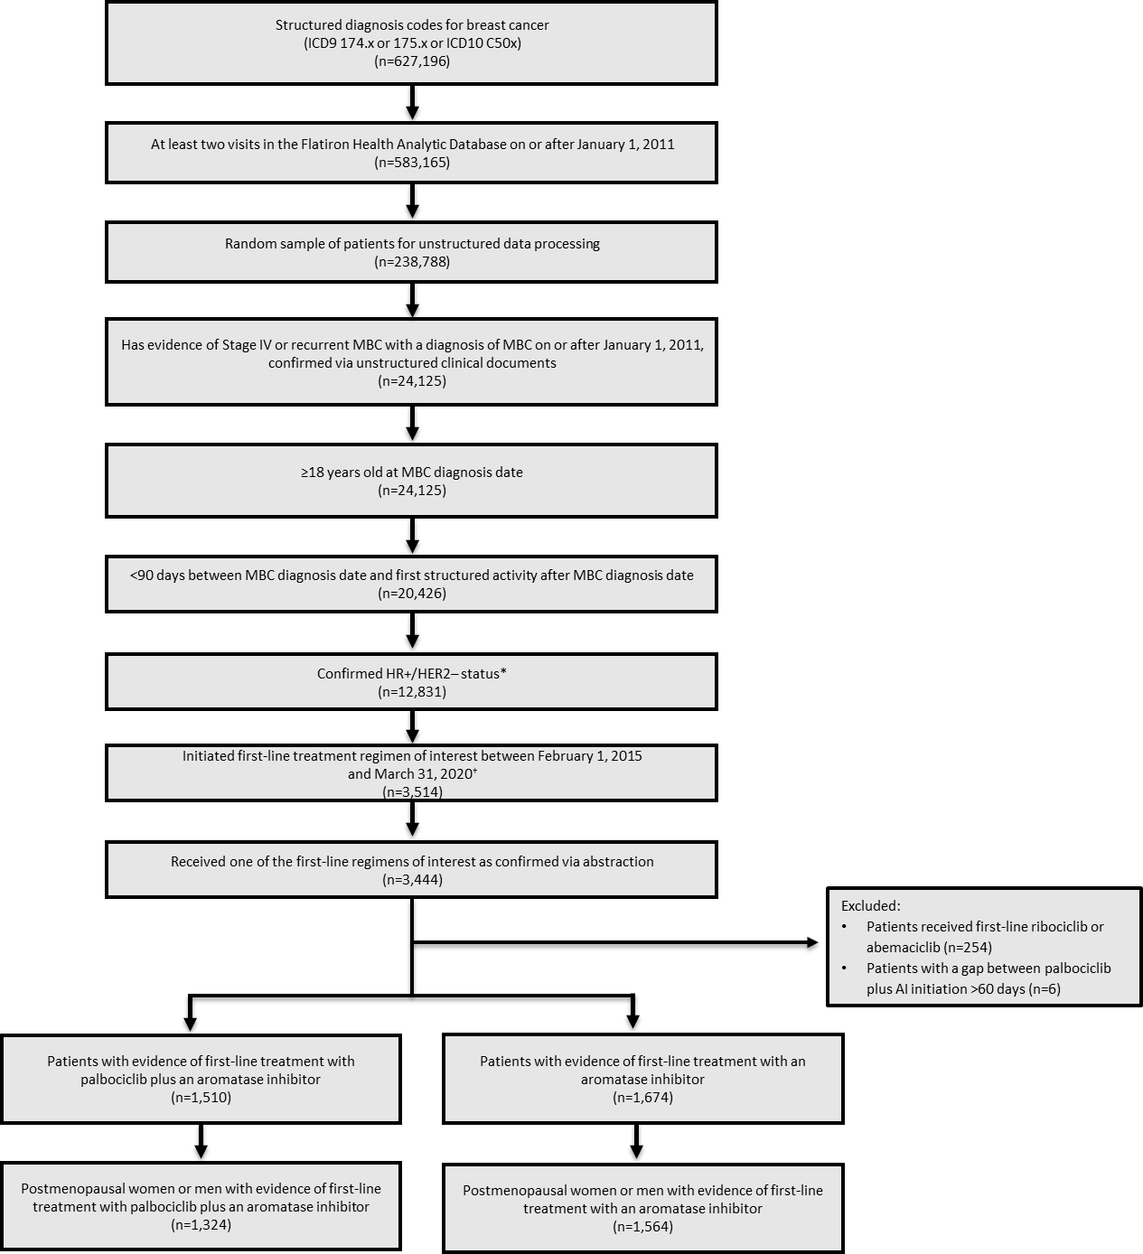

Figure 2. Kaplan-Meier curves of overall survival.

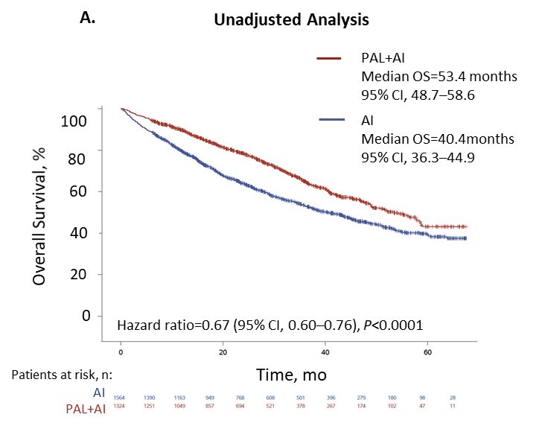

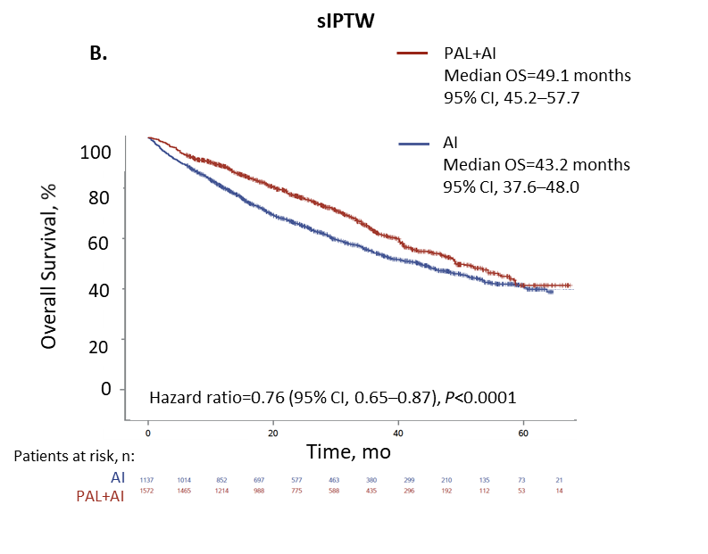

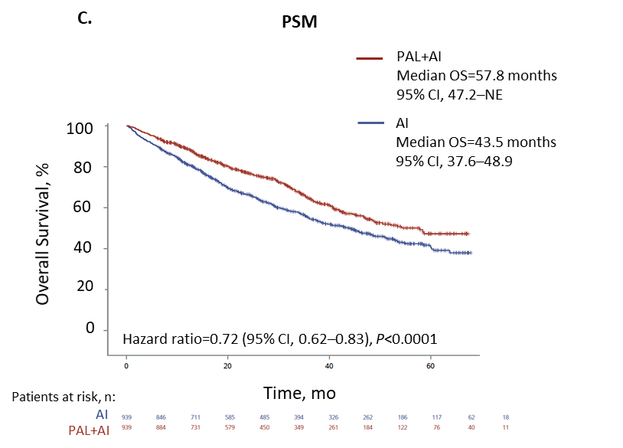

AI=aromatase inhibitor; NE=not estimable; OS=overall survival; PAL=palbociclib; PSM=propensity score matching; sIPTW=stabilized inverse probability of treatment weighting.

Figure 3. Forest plot of overall survival by subgroup after sIPTW.

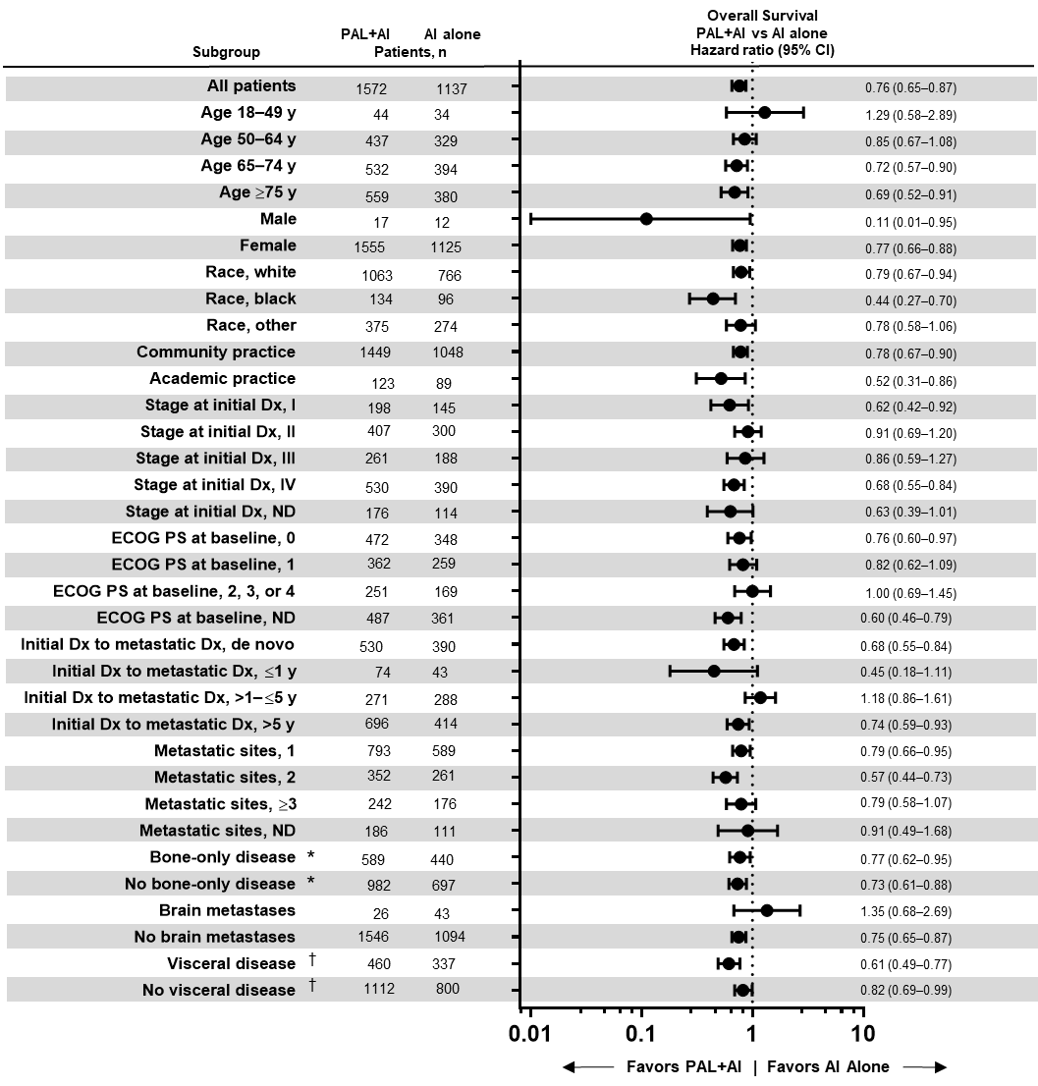

AI=aromatase inhibitor; Dx=diagnosis; ECOG PS=Eastern Cooperative Oncology Group performance status; ND=not documented; PAL=palbociclib; sIPTW=stabilized inverse probability of treatment weighting.

†Visceral disease was defined as metastatic disease in the lung and/or liver; patients could have had other sites of metastases. No visceral disease was defined as no lung or liver metastases.

‡Bone-only disease was defined as metastatic disease in the bone only.

Figure 4. Forest plot of overall survival by subgroup after PSM.

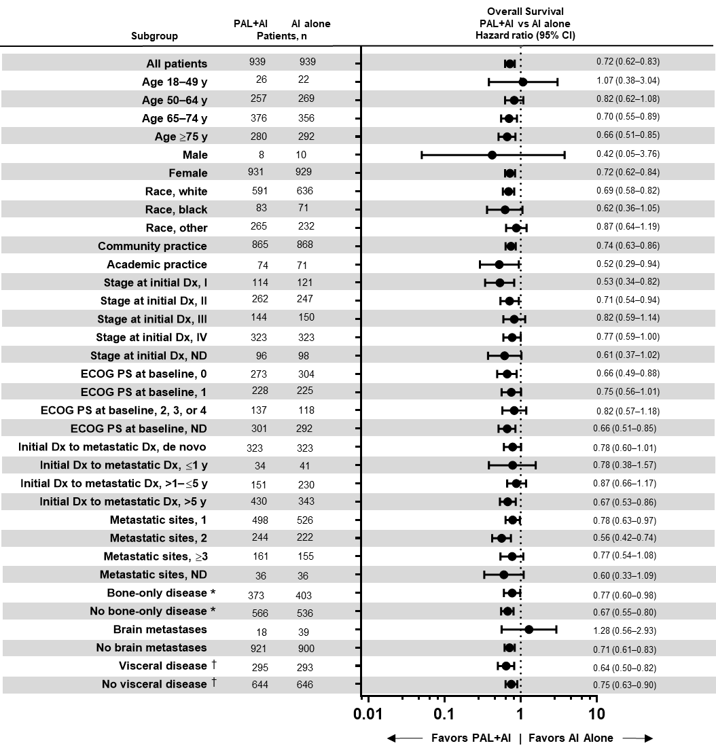

AI=aromatase inhibitor; Dx=diagnosis; ECOG PS=Eastern Cooperative Oncology Group performance status; ND=not documented; PAL=palbociclib; sIPTW=stabilized inverse probability of treatment weighting.

†Visceral disease was defined as metastatic disease in the lung and/or liver; patients could have had other sites of metastases. No visceral disease was defined as no lung or liver metastases.

‡Bone-only disease was defined as metastatic disease in the bone only.

Figure 5. Kaplan-Meier curves of real-world progression-free survival.

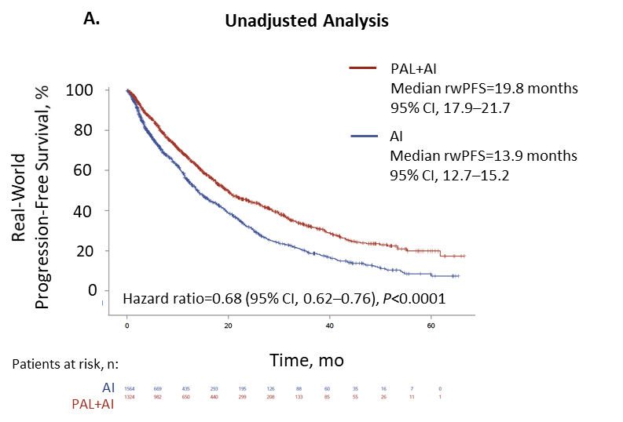

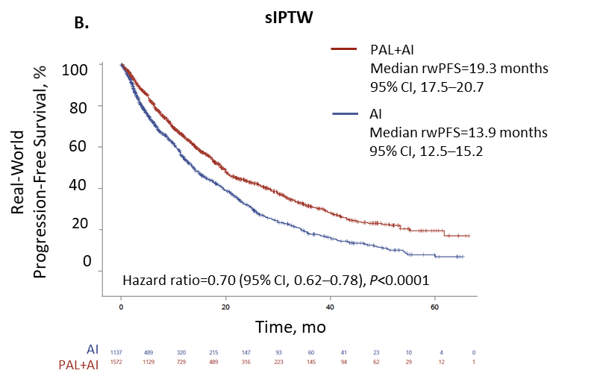

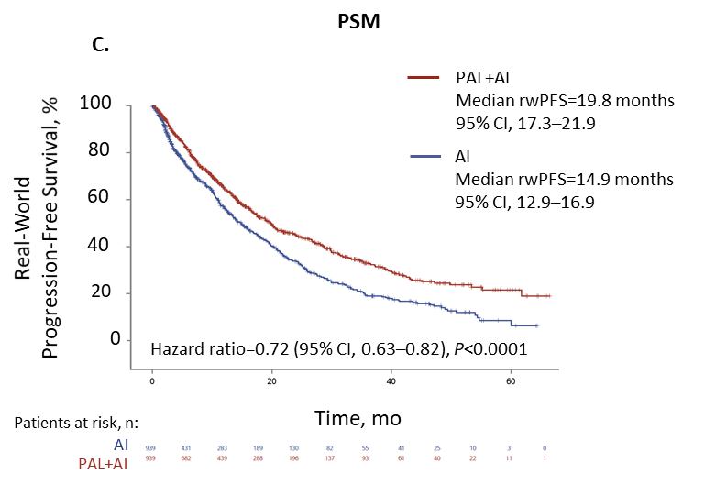

AI=aromatase inhibitor; PAL=palbociclib; rwPFS=real-world progression-free survival; PSM=propensity score matching; sIPTW=stabilized inverse probability of treatment weighting.

Figure 6. Forest plot of real-world progression-free survival by subgroup after sIPTW.

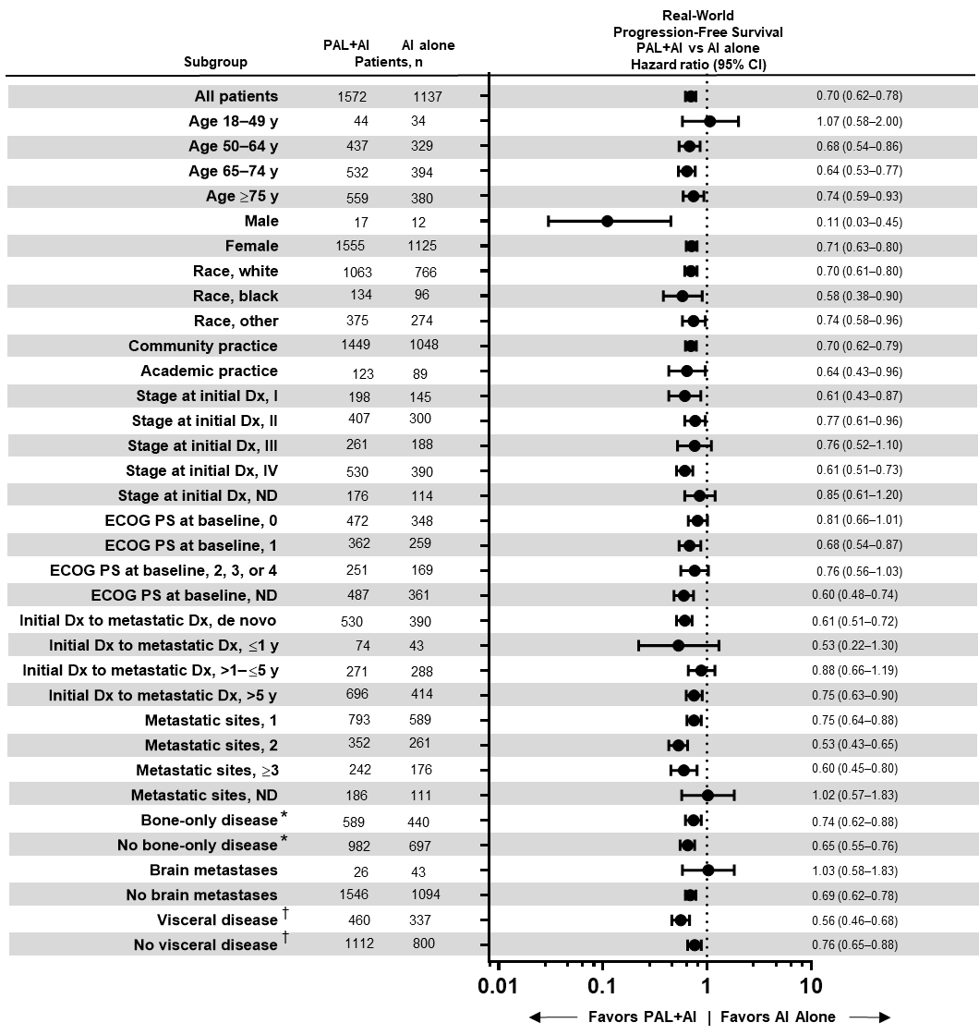

AI=aromatase inhibitor; Dx=diagnosis; ECOG PS=Eastern Cooperative Oncology Group performance status; ND=not documented; PAL=palbociclib; sIPTW=stabilized inverse probability of treatment weighting.

†Visceral disease was defined as metastatic disease in the lung and/or liver; patients could have had other sites of metastases. No visceral disease was defined as no lung or liver metastases.

‡Bone-only disease was defined as metastatic disease in the bone only.

Figure 7. Forest plot of real-world progression-free survival by subgroup after PSM.

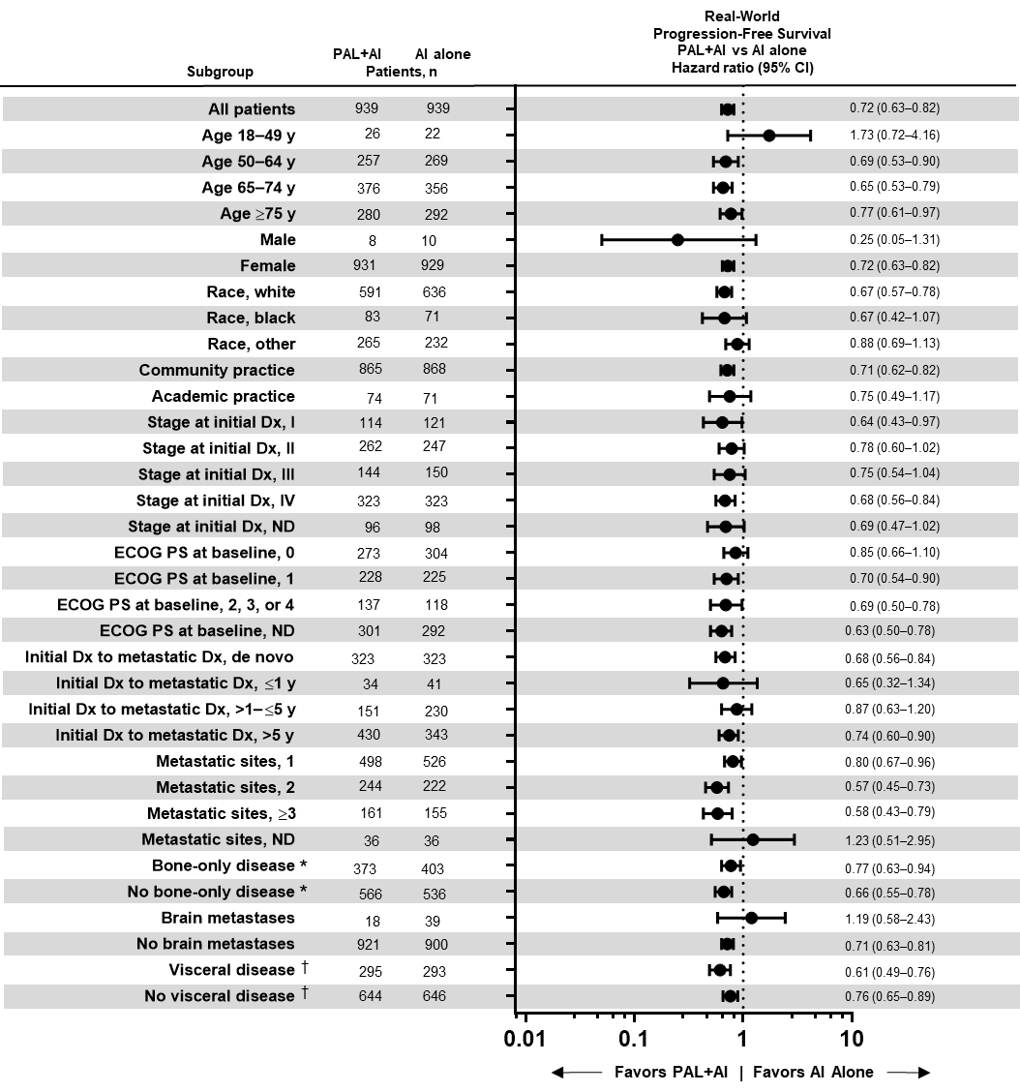 AI=aromatase inhibitor; Dx=diagnosis; ECOG PS=Eastern Cooperative Oncology Group performance status; ND=not documented; PAL=palbociclib; sIPTW=stabilized inverse probability of treatment weighting.

†Visceral disease was defined as metastatic disease in the lung and/or liver; patients could have had other sites of metastases. No visceral disease was defined as no lung or liver metastases.

‡Bone-only disease was defined as metastatic disease in the bone only.

Supplementary Material

Methods

Data are derived from 42 distinct states (including Puerto Rico and Washington DC); state-level or geographic filters were not selected. The state is missing for a small proportion of patients for whom the state of residence was not recorded in the physician's records. For de-identification reasons, state is nulled out for all Academic patients and a few low-population states for all patients (ie, AK, MT, ND, SD, VT, WY). Any territories outside of the 50 states, District of Columbia, and Puerto Rico are reported in the State field as NULL.